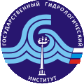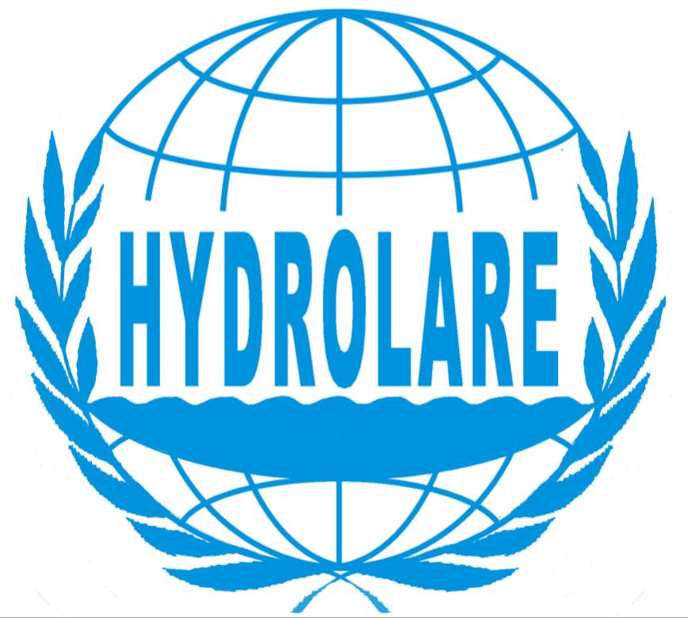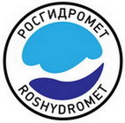

Sixth Meeting of the Steering Committee
for the International Data Centre
on Hydrology of Lakes and Reservoirs
(HYDROLARE)

FINAL REPORT

St. Petersburg, Russian Federation, 18 – 20 July 2017
TABLE OF CONTENTS

1. Welcome 3
1.1. Introduction of participants and adoption of the Agenda 3
2. Status Report of HYDROLARE 3
2.1. Progress Report September 2015 – July 2017 3
2.2. Status of the HYDROLARE Database 5

2.3. Development of the HYDROLARE IT Infrastructure 6
3. Presentations from collaborating partners 8
3.1 Status report of Hydroweb 8

3.2 Workshop Lakes, remote sensing and climate 11

3.3 GRDC. Current activities and future plans 12

4. Review of GTN-H activities 12
5. Recent decisions of the WMO Congress and CHy related to hydrology and data centres 13
6. GCOS program and its connection with HYDROLARE 15
7. HYDROLARE activities until July 2019 16
8. Final Remarks 19
9. Closure of the Sixth Steering Committee of HYDROLARE 19
Annex 1 Final Agenda 20
Annex 2 List of Participants 22

Sixth Meeting of the Steering Committee for the International Data Centre on Hydrology of Lakes and Reservoirs
(HYDROLARE)

18 – 20 July 2017, St. Petersburg, Russian Federation

1. Welcome

The Sixth HYDROLARE Steering Committee Meeting was opened at 11:00 on the 18 July 2017 by Dr Mikhail Markov, Deputy Director for Science of the State Hydrological Institute. Dr Markov welcomed the participants to the sixth session of the HYDROLARE Steering Committee. In his welcome remarks he provided a brief summary of the history of establishment, role and functions of HYDROLARE and wished the Steering Committee fruitful and efficient discussions.

………………………………………………………………………….…………………………………..

1.1. Introduction of participants and adoption of the Agenda

Participants were introduced to each other and after a short discussion, the agenda was adopted. The agenda is provided in Annex 1 and the list of participants in Annex 2.

…………………………………………………………………………………………….………………..

2. Status Report of HYDROLARE

2.1. Progress Report September 2015 – July 2017

The Director of HYDROLARE Prof. Valery Vuglinsky provided an in-depth report on the status of activities and achievements made in the period from September 2015 to July 2017. In his report Prof. Vuglinskiy noted that during the reporting period the Centre operated in accordance with the work plan adopted by Roshydromet and following the recommendations of the fifth Steering Committee meeting. This report was highly appreciated by participants as it showed the significant progress made in the reporting period. Participants acknowledged the dedicated professional work of the staff of HYDROLARE in this regard.

Specific items of interest are documented below and are summarized in the table of achievements made throughout the reporting period.

Main directions of HYDROLARE activity after the fifth session of the Steering Committee:

- further development of the HYDROLARE database, collection of information and
database maintenance;
- website maintenance;
- cooperation with Legos;
- integration of in situ (HYDROLARE) and remote sensing (Hydroweb) lake databases;
- preparation of sixth and seventh issues of annual newsletter.

In particular, during the intersessional period HYDROLARE:

- substantially increased and updated its data holdings (currently data for 1103 lakes and reservoirs and 1121 stations from 48 countries);
- continued work on integration of in situ and remote sensing lake databases (improved compatibility with new Hydroweb website opened in 2016);
- continued work on comparison of in situ and satellite data;
- enhanced data content by adding a new type of data (maximum ice thickness) to the database;
- enhanced informational content (new functionality – display of GRDC river stations on rivers flowing in out of the HYDROLARE lakes);
- developed a metadata catalogue and made it available on the website;
- provided input to the new GCOS Implementation Plan 2016 (a list of actions for the ECV Lakes);
- took part in the lake workshop organized by Legos/CNES (June 2017, Toulouse, France).

Prof. Vuglinskiy made a short description of each activity, and underlined the success achieved by HYDROLARE in this regard.

Main achievements of HYDROLARE up to July 2017
based on the Milestones for HYDROLARE
defined during the Sixth Steering Committee Meeting

Action
Continue preparation and loading of new portions of historical data from Russia and former USSR countries into HYDROLARE database
Continue preparation and loading of new metadata and historical observation data from WMO member countries (outside former USSR) into HYDROLARE database
Enhance the database structure and the HYDROLARE IT infrastructure to include new types of data (ice thickness data)
Collection, analysis and preparation for upload of the following new types of data from WMO Members:
– water temperature data
– ice thickness data
Provide data products (combined graphs of water level) based on terrestrial and satellite-based observations
At country level, visualize in interactive maps water bodies in the HYDROLARE database together with basic identification (i.e. name)
Document metadata in HYDROLARE and Hydroweb and provide a metadata catalogue on the website
Provide inputs for next GCOS Implementation Plan
Update HYDROLARE Science and Applications plan, take into account latest official documents of WMO, GCOS (TOPC) in hydrology, and evolving tasks
Update a list of organizations which have observation data for hydrology of lakes and reservoirs on the HYDROLARE website
Prepare official reports on HYDROLARE in 2015 and 2016 for WMO and Roshydromet
Prepare HYDROLARE newsletters (sixth and seventh issues)
In conclusion, Prof. Vuglinsky evoked the need to specify the status, main areas of activity and principles of interaction of the global hydrological data centres in the context of continued implementation of the WMO Hydrological Observing System (WHOS) following Resolution 15 (CHy-15). As is known, before the establishment of WHOS, the above centres were considered at part of the WMO Information System (WIS) with a status of Data Collection or Production Centres (DCPCs) and the related functions within this information system. The emerging new information system (WHOS), implementing a number of new methods and technological approaches to collection, processing and dissemination of data, requires that the roles and functions of the global data centres be defined more precisely.
………………………………………………………………………………………………..……………..

2.2. Status of the HYDROLARE Database

Ms Elena Kuprienok provided information on the status of data acquisition from national institutions and data centres. She reminded the Committee about general database structure and content and that in 2016 and 2017 the centre continued collection and preparation of data from WMO Members, with priority given to water level data (Table 1).

Table 1. Water level data in the database

Country | Number  of stations | Levels at stations | Number  of lakes | Mean monthly lake levels | Lake levels at the first date of each month
Australia |  |  | 220 | 1990 – 2012
Armenia | 8 | 1938 – 2013 | 1 | 1938 – 1988 | 1938 – 1988
Belarus | 32 | 1901 – 2009
Cyprus |  |  | 18 | 2010 – 2012 | 2010 – 2012
Estonia | 23 | 1921 – 1988
Finland | 36 | 1847 – 2013
Georgia | 22 | 1928 – 1988
Kazakhstan | 88 | 1934 – 2008 | 5 | 1934 – 2008 | 1934 – 2008
Kyrgyzstan | 16 | 1927 – 2012 | 1 | 1958 – 2012 | 1958 – 2012
Latvia | 31 | 1925 – 1988 | 1 | 1978 – 1988 | 1978 – 1988
Mexico |  |  | 115 | 1930 – 2014 | 1930 – 2014
Moldova | 7 | 1955 – 2010 | 2 | 1968 – 1988 | 1968 – 1988
Mongolia | 15 | 1963 – 2013
Russian Federation | 603 | 1859 – 2016 | 34 | 1914 – 2015 | 1914 – 2015
Slovenia | 3 | 1919 – 2014
Sweden | 6 | 1858 – 2015
Switzerland | 34 | 1856 – 2015
Turkmenistan | 8 | 1952 – 1989 | 5 |  | 1958 – 1989
Ukraine | 88 | 1933 – 1988 | 8 | 1952 – 1988 | 1952 – 1988
United States of America | 43 | 1860 – 2016 | 7 | 1918 – 2016 | 1860 – 2000
Uzbekistan | 12 | 1946 – 1988 | 2 | 1959 – 1988 | 1959 – 1988
Total | 1075 |  | 419

Ms Kuprienok informed the Committee that in 2016 the database was expanded to include new type of data – water temperature at stations. So far, HYDROLARE has received and uploaded water temperature time series (mean monthly and maximum) from 319 stations in nine countries.

Upon the recommendation of the HYDROLARE International Steering Committee, HYDROLARE began collecting data on the Caspian Sea as it is included in the priority list of lakes for sustained monitoring established by GCOS. To date, water level time series from 24 Caspian stations and mean monthly water temperature time series from 19 stations are available in the database.

In conclusion, Ms Kuprienok expressed her concern regarding the situation with data provision and update. She mentioned that the only country that provides regular update was Switzerland. On the positive side, Ms Kuprienok noted that the database contains data for many countries with large lakes or even vast lake regions such as Finland, Russia and USA.

Participants commented on the efforts that had resulted in the acquisition of data and observations, including metadata from a number of countries.

…………………………………………………………………………………………………………..

2.3. Development of the HYDROLARE IT Infrastructure

Dr Ludmila Barinova informed the meeting on the recent developments of the HYDROLARE IT infrastructure. In 2015, special software was developed enabling to upload water temperature station data and display information on availability of these data on the website.

Major advancements in 2016-2017:

- Inclusion of maximum ice thickness data in the database.

- Display of GRDC stations connected with HYDROLARE lakes and reservoirs on the HYDROLARE website.

- Development of the catalogue of lakes and reservoirs.

In 2017, the IT-infrastructure was further developed to include new type of information – maximum ice thickness data – to the database.

Therefore, technological opportunities have been created to upload all three types of information (water level, water temperature and ice thickness) envisaged by the initial concept of the centre (Figure 1).

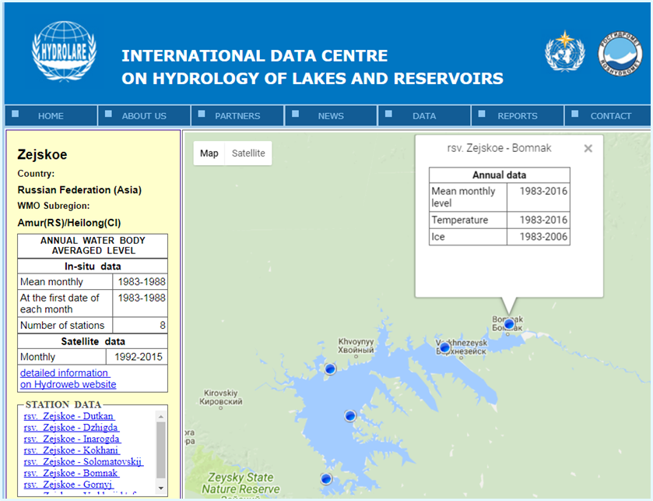

Figure 1. Web page providing information on all three types of data

For HYDROLARE lakes and reservoirs, hydrographic connection with inflowing and outflowing rivers has been established. Stations on these rivers have been selected from the GRDC database (166 stations on 70 reservoirs).
These stations are displayed on the HYDROLARE website. For them, the possibility to obtain runoff data from the GRDC website has been created (Figure 2).

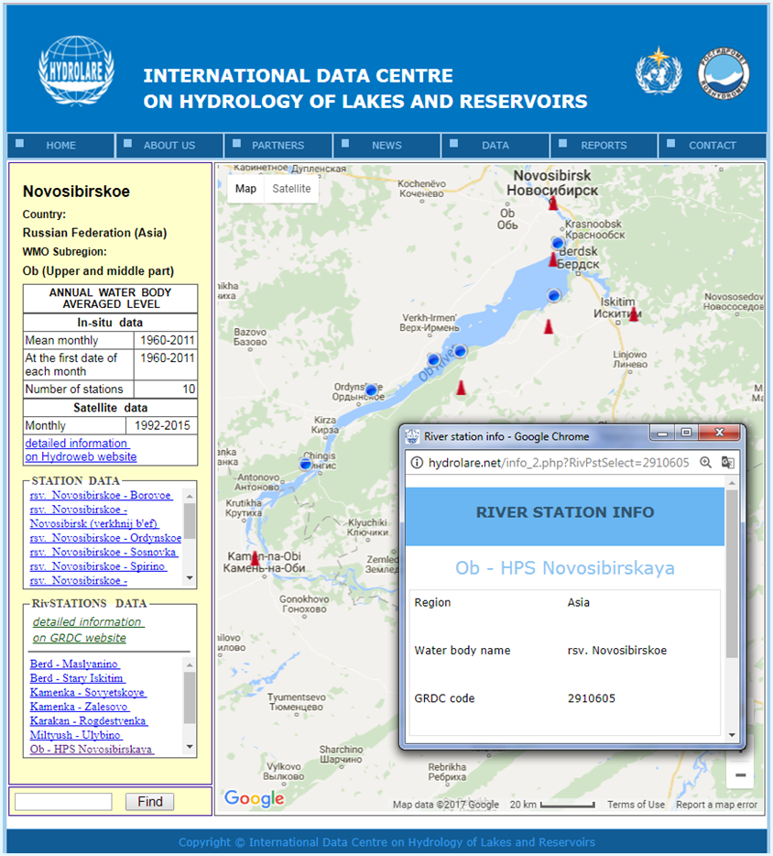

Figure 2. GRDC river station info on the HYDROLARE website.

Therefore, for some HYDROLARE lakes, the full information content includes seven types of data either available directly from HYDROLARE or by using the links to corresponding websites (Hydroweb, GRDC). These include:

1. Mean monthly lake water level.
2. Lake level at the first date of each month.
3. Mean lake water level from satellite.
4. Mean monthly level at stations .
5. Maximum water temperature at stations.
6. Maximum ice thickness at stations.
7. Stations on inflowing and outflowing rivers.

In 2017, the website has been updated with a metadata catalogue of lakes and reservoirs available in the HYDROLARE database. The catalogue in the form of an Excel spreadsheet is available on the website.
…………………………………………………………………………………………………….………..

3. Presentations from collaborating partners

3.1 Status report of Hydroweb

In January 2016, the new Hydroweb database has opened with much new functionality. This database is implemented on the THEIA platform under funding of the French Investment Program in the framework of the preparation of the wide-swath altimeters SWOT (Surface Water and Ocean Topography) mission.
Currently Hydroweb produces water level variations of 160 lakes worldwide. Among them, the surface extent and the volume variations of about 100 lakes are also measured using satellite imagery. For 60 lakes monitoring and processing is performed in near real time and these data are fully opened to the scientific community without any restrictions and free of charge.

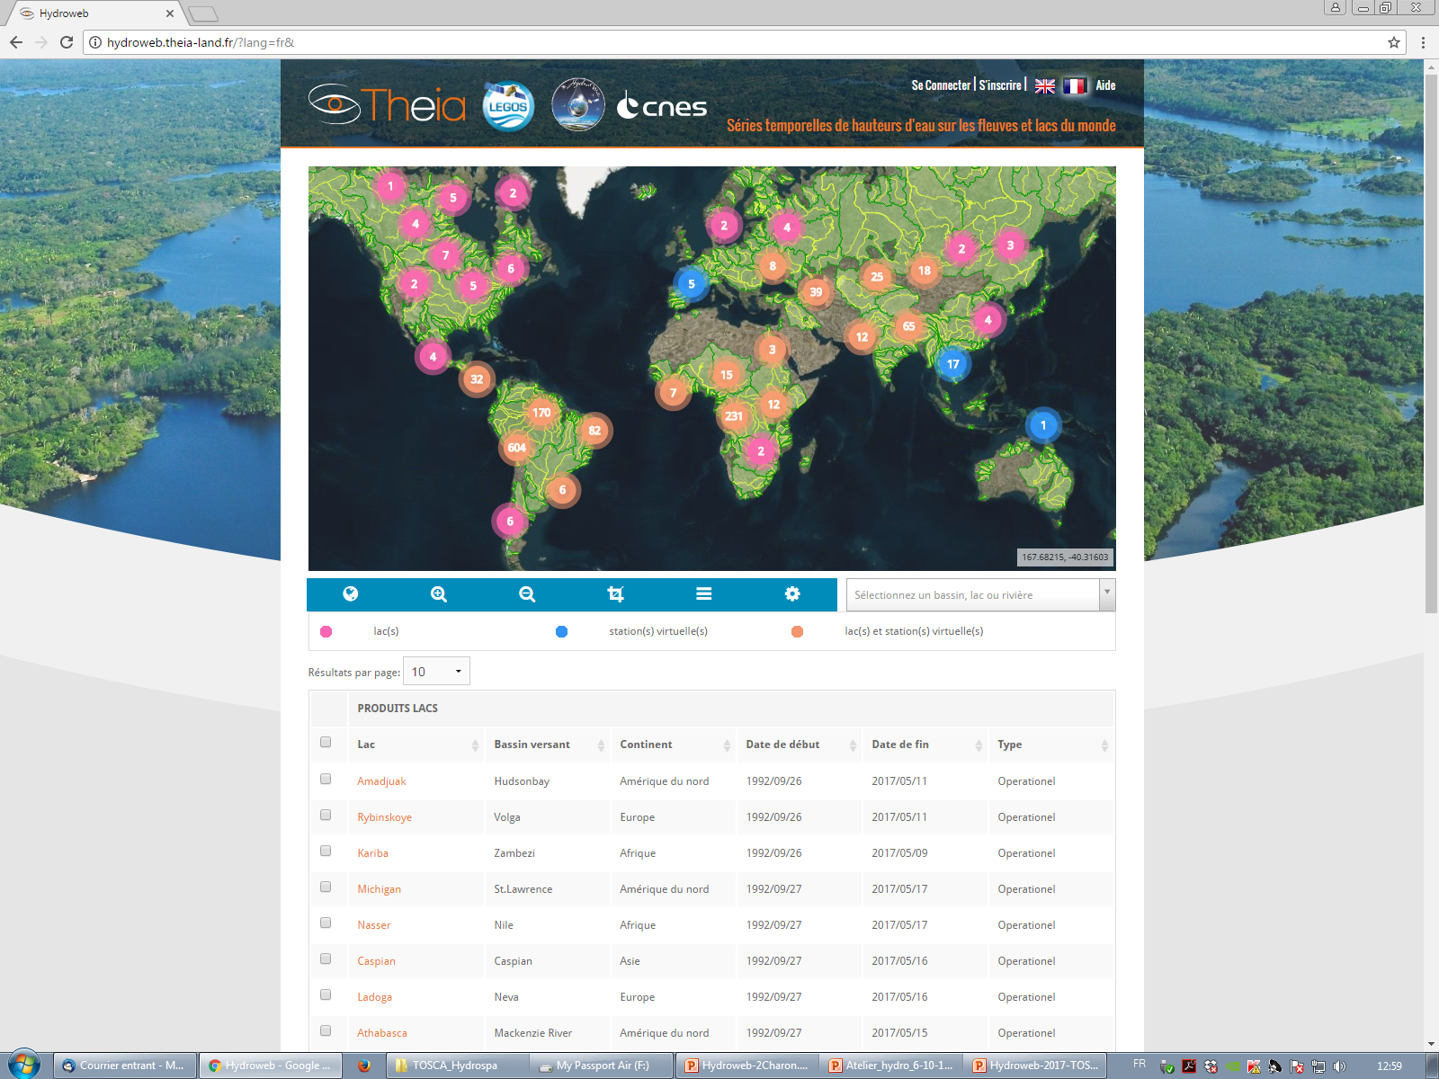

Figure 3. Site developed by Legos

LEGOS is the official partner of HYDROLARE for the delivery of lake level from satellite altimetry. Several studies for validation of satellite products using Hydrolare in situ database have been performed in the framework of mutual cooperation. Below is a table summarizing the results of comparison under different situations (big or small lakes, in mountain or plain area) which shows the disparity of quality of satellite altimetry. It ranges from 2-3 cm for large lakes to1 meter for small or narrow reservoirs like the Guri or the lake Powell.

Table 2. Altimetry over lakes: comparison with in situ data

Lake name | Continent | Area (km²) | Period | RMS (cm) | R²
Argentino¹ | South Am | 1466 | 1992-2011 | 22 | 0.96
Athabasca² | North Am | 7900 | 1992-2009 | 28 | 0.91
Aydarkul³ | Asia | 3000 | 2002-2010 | 12 | 0.95
Baikal⁴ | Asia | 31500 | 2002-2013 | 6 | 0.94
Bratsk⁴ | Asia | 3100 | 1992-2009 | 41 | 0.98
Erie² | North Am | 25800 | 1992-2011 | 10 | 0.95
Guri² | South Am | 3500 | 2002-2010 | 82 | 0.99
General Carrera¹ | South Am | 1850 | 2002-2010 | 22 | 0.90
Huron² | North Am | 59570 | 1992-2011 | 8 | 0.99
Issykkul⁶ | Asia | 6000 | 2002-2014 | 3 | 0.99
Khanka⁴ | Asia | 4400 | 2000-2010 | 13 | 0.6
Ladoga⁴ | Europe | 18135 | 1992-2010 | 8 | 0.98
Mead⁵ | North Am | 350 | 2001-2010 | 64 | 0.99
Michigan² | North Am | 58000 | 1992-2011 | 11 | 0.98
Oahe⁶ | North Am | 700 | 2002-2010 | 45 | 0.99
Onega⁴ | Europe | 18200 | 1992-2010 | 15 | 0.88
Ontario² | North Am | 19000 | 1992-2011 | 6 | 0.98
Powell⁵ | North Am | 400 | 1992-2010 | 85 | 0.99
Superior² | North Am | 82200 | 1992-2011 | 6 | 0.97
Tana² | Africa | 3000 | 1992-2006 | 17 | 0.97
Tchad² | Africa | 1540 | 1992-2008 | 28 | 0.91
Titicaca⁷ | South Am | 7800 | 2000-2005 | 7 | 0.99
Volta² | Africa | 8500 | 1999-2010 | 53 | 0.98
Woods² | North Am | 4350 | 1992-2011 | 27 | 0.81

In the future, the new instruments will be better designed for inland studies with SAR technology allowing a much better quality for all type of lakes and rivers.

LEGOS is now preparing a joint proposal to the CCI+ (Climate Change Initiative) of ESA (European Space Agency) call for new ECV (Essential Climate Variables) that include, inter alia, important climate indicators (Williamson, 2009; Schindler, 2009) such as water extent, water color, ice cover duration and depth.

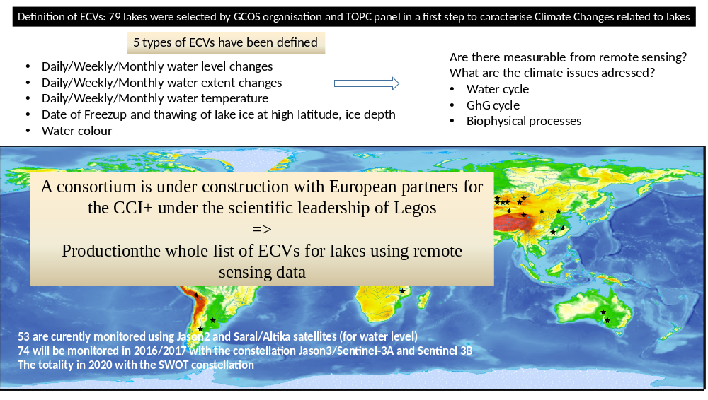

Figure 4. New CCI+ initiative

A consortium with France, UK, Canada, Switzerland, Norway, and Russia will be setup to submit a proposal for monitoring these ECVs for lakes. The purpose is to develop benchmarking in order to select satellite missions and methodologies to provide the ECVs from space data. The results of the project will enable to obtain data on new climate indicators for lakes with required precision using satellite altimetry in collaboration with ESA and GCOS. HYDROLARE is proposed to participate in the project as an international data centre responsible for delivery of data on ECV-Lakes under GCOS project.

3.2 Workshop Lakes, remote sensing and climate

The first workshop on lakes, remote sensing and climate (1-2 June 2017, Toulouse, France) was organized by LEGOS/CNES. Participants discussed current situation in lake studies with regard to climate change. Some of the key questions discussed:
- What are the most needed satellite data sets in limnology, are current sensors adequate, do we need new sensors?

- How to organize international community of remote sensing data providers to make data useful for lakes more accessible to the science communities, and what are the recommendations for short term funding & long-term observation plans related to lakes?

- Can we understand climate change impacts on lake ice, lake temperature, lake hydrology, and lake biogeochemistry independently, or are changes only understandable through coupled analysis, with integrated data analysis?

- Is there a need to revise the definition of the ECVs defined by GCOS?

- Is there a joint field (including airborne) & remote sensing campaign that we could plan that would address key questions related to lakes?

Some key recommendations developed:

- It is needed to develop global ecological Lake Network with in situ instrumentation on a high range of variables to measure, for:

- satellite data calibration and validation
- assimilation into models
- comprehension of the long term changes in a multi variable point of view

- There is a lack of global classification of lakes under different criteria (morphological, climatic, physical, biogeochemical).

- To set up a network of lakes with adequate and pertinent classification is therefore a necessity together with an integrated database of inter-calibrated various climate records.

- Constitute a working group on Lakes, Remote Sensing and Climate with regular workshops and prepare a white paper by the end of the year.

3.3 GRDC. Current activities and future plans

The Head of GRDC Dr Ulrich Looser provided an in-depth overview of the status of the GRDC database, data users, as well as products and services disseminated by GRDC. He presented summary statistics of the database including global coverage of the stations by time series length, time series end, by WMO Regions and over time.

Established in 1988, GRDC operates under the auspices of the World Meteorological Organization with the original mandate to collect, store and disseminate historical discharge data and derived data products. Currently GRDC is offering data and data products for more than 9300 stations in 160 countries. In 2015-2017 GRDC has received updates from more than 15 countries including Russia.

The GRDC supports international climate-related projects of the United Nations and agencies such as UNESCO, GCOS, GEO etc. and provides data for climate studies, research and assessment, as well as for climate services and climate and hydrological modeling.

Summary statistics of data and information requests directed to GRDC have been presented. Since the previous HYDROLARE SC the total number of requests has increased by more than 10% amounting to more than 460 requests handled in 2016, of which some 15% are the requests for global GIS layers and technical support.

In the end of his presentation, Dr Looser informed the meeting that due to lack of resources and skills in-house maintenance of the database is no longer possible, therefore a migration process to a new WISKI DBMS was started in October 2016.

4. Review of GTN-H activities

The coordinator of GTN-H Dr Wolfgang Grabs provided an overview of the GTN-H network with a focus on lakes and reservoirs. Established in 2001 as a joint effort of WMO, GCOS and GTOS, GTN-H links existing networks and systems for integrated observations of the global water cycle with the aim to maintain a global hydrological “network of networks”. It facilitates access to hydrological and related networks and observation data and generates derived products. HYDROLARE holds its place among GTN-H data centres providing data and information on the essential GCOS climate variables. The role and purpose of HYDROLARE in GTN-H is to provide baseline information on variations of surface freshwater storage; hydrological information for limnological and environmental assessments; quantitative information that is essential for the management of lakes and reservoirs and baseline information for the parameterization of lakes in numerical weather prediction and climate modeling. As a repository of an important component of global surface water storage and its variation, HYDROLARE constitutes an important component for water resources assessments on all scale levels.

Dr Grabs presented a list of upcoming and ongoing GTN-H tasks among which are the following:

- Improve registration of metadata and datasets to existing GEO-Infrastructures (such as WMO-WIGOS, GEOSS-Portal) to improve visibility and access to data and observations;

- Work on a concept of Basic Regional Networks of all Essential Climate Variables to identify strengths and weaknesses of an Integrated Earth Observation System for Climate and identify investment opportunities to improve these networks;

- Strengthen in situ observations through efforts of the federated data centres, where feasible including complementary satellite observations;

- Continue efforts undertaken to improve the interoperability of the exchange of data as a milestone for enhanced efforts to develop tailored data products from a multitude of databases;

- Mainly through GRDC, continue to cooperate with the Open Geospatial Consortium (OGC) and its HydroDomain Working Group to make further progress in matters related to standards and standardization of communication including the use of Water–ML.

One of the issues that has been recently brought for discussion to the GTN-H community is the new GEO Community Activity “Terrestrial in situ observations, standards, archiving, analysis and dissemination” and in particular its new sub-activity Surface Water Storage. During the 8th Session of the GTN-H Panel (20-21 June, Koblenz, Germany) possible ways were discussed of providing the possible support for this new GEO initiative which include mainly surface water storage of lakes and reservoirs and storage in river channels.
HYDROLARE is seen among entities that will play a major role in the development of this activity which would include, inter alia: GloboLake, Legos/CNES, France (altimetric lake level observations and volume change computations) and possibly City College of New York (CUNY), USA (water storage in river channels).

Another issue that was discussed during the GTN-H Panel Session is the augmentation of in situ observations with satellite-based observations. HYDROLARE is pioneering the development of methods in this regard. The first results were presented and the GTN-H partners discussed the potential of making use of remote sensing information to augment in situ observations on a complementary basis.

……………………………………………………………………………………………………………….

5. Recent decisions of the WMO Congress and CHy related to hydrology and data centres

The representative of WMO Dr Dominique Berod provided information on recent decisions of the WMO Congress and CHy related to hydrology. In particular, he mentioned that WMO is developing main initiatives in support of basic systems in hydrology:
- World Hydrological Cycle Observing System (WHYCOS) – data collection and production;
- Meteorological, Climatological and Hydrological (MCH) Database Management System – data processing and storage;
- WMO Hydrological Observing System (WHOS) – data visibility and sharing;
- Global Data Centres (GRDC; HYDROLARE; IGRAC) – data rescue and services.
WHYCOS and WHOS will be further developed under the umbrella of the newly established HydroHub (Global Hydrometry Support Facility, including an Innovation Hub), together with a Help Desk and a hydrological services information Platform. The goal of the HydroHub is to strengthen the global hydrometry mandate of WMO by developing an efficient, innovative and sustainable operational framework for hydrometry and data management. The HydroHub is designed to mobilize and bring together actors of the water community and beyond, to support the full value chain – from data collection to knowledge sharing – by building on past and current capacities, while enabling innovative approaches, delivering technical assistance and facilitating free and open data sharing for international cooperation.
The HydroHub:
- Bridges the gap between the observation needs and the appropriate innovative technologies (e.g., low-cost technology, citizen observations, …);
- Provides new ways of using data for decision, e.g. information systems;
- Integrates innovation into more traditional measuring instruments, e.g. through citizen observations.
The activities of HydroHub in 2017 include:

- Meetings of the Advisory Council and Innovation Committee;
- Preparation of the first innovation call;
- Support of H2020 proposals;
- Proposals for new HYCOS projects (IGAD, Senegal);
- Outreach material;
- Reaching out to partners.

At the recent session of the Commission for Hydrology (CHy-15) the following resolutions were adopted that are of direct relation to data centres and HYDROLARE in particular:
- Resolution 4: Governance of the Global Hydrometry Support Facility: Advisory Council and Innovation Committee;
- Resolution 5: Further implementation of WHOS Phase I as well as initial concept of WHOS Phase II, implementation plan to be presented to EC-70;
- Resolution 8: Initiate the WMO Global Hydrological Status and Outlook system, building on the existing efforts from a number of Members to produce regular analyses of the current national hydrological condition complemented by forward looking assessments of how the water situation may change over sub-seasonal to seasonal time scales, and taking into consideration the need to link this initiative closely with other related WMO activities such as WIGOS (in particular by making use of the opportunities provided by WHOS) and the Global Data-processing and Forecasting System.
Dr Berod also informed the meeting that in its Resolution 15 — Data operations and management CHy-15 requested the president of Commission «to form a small task team in charge of preparing a report to the Executive Council with regard to the evolving role of the GRDC, IGRAC and HYDROLARE and their relationship with WMO, with respect to the monitoring and measurement of the achievement of the Sustainable Development Goals, their contributions to the Global Framework for Climate Services and support to the WMO Hydrological Observing System, Global Hydrometry Support Facility and other CHy initiatives».
Phase II of WHOS aims at developing a complete services-oriented hydrologic information system that enables data registration, discovery and access, in compliance with WIS and WIGOS. WHOS will support storage of hydrological information, its publication on the Internet via web-services, combining it with hydrological data published by multiple sources, and search across the various data holdings within a network.
EC-69 approved its development by decision 49 - WMO priority actions in hydrology and water resources management - …to give high priority to the development of operational WHOS Phase II components - and invited Members to support WHOS. Phase II as an essential part of WIGOS and to grant free and unrestricted access to hydrological data.

Other EC-69 data centres related decisions:

- Amend the Manual on Codes and the Guide to Hydrological Practices to introduce WaterML2 Part 1 (Time series) and 2 (streamflow information) as data representations that are suitable for the exchange of hydrological information; Work with OGC;

- Contribution to WIGOS and GCOS;

- Invites Members and regional associations, in particular through their working groups related to hydrology and water resources management, to make all the necessary efforts to support the activities pertaining to advancing the implementation of CHy Advisory Working Group’s workplans for 2016 to 2019.

Dr Berod also reported that WMO is planning to hold the Global Conference on “Prosperity through Hydrological Services” in Geneva on May 7-9 2018. Given topics could include, inter alia, the issue of the roles and functions of global data centres on hydrology.
In conclusion, Dr Berod mentioned that global data centres such as HYDROLARE are expected to play a key role in implementation of all the above mentioned activities.

………………………………………………………………………………………………………………

6. GCOS program and its connection with HYDROLARE

On behalf of the GCOS secretariat, Dr Berod outlined specific GCOS activities related to HYDROLARE. He noted, in particular, that, in addition to improving climate science, the new GCOS Implementation Plan (GCOS-200) emphasizes the need to support adaptation to climate change. In this plan, new requirements for the different ECV products, including lake water level, water extent, surface water temperature, lake ice thickness, ice cover and lake color, have been defined. The next step would be to identify the networks to observe this information, possible repositories and ways to access the data. HYDROLARE is expected to provide this information to GCOS.
The TOPC is aimed at developing a balanced and integrated system of in situ, air and space-borne observations of the terrestrial ecosystems. With regard to lake levels, TOPC focuses on continuous improvement of Lakes ECV by improving the technique of satellite water level measurements by comparative analysis of the results of satellite and in situ observations to explore the impact of different factors on the accuracy of satellite water level measurements and by establishing trial products on lake surface temperature and ice thickness.
HYDROLARE has provided input to the new 2016 GCOS Implementation Plan regarding the Essential Climate Variable (ECV) Lakes. Specific lake actions in the GCOS IP include:

- Improve data submission and exchange:
  - Exchange of hydrological data (WMO resolutions 25 (Cg-XIII) and 40 (Cg-XII) (T7);
  - Submit historic and current monthly lake-level data (T9);
- Improve use of satellite observations;
  - Establish sustained production and improvement for the lake ECV products (T8) (i.e. lake-surface temperature, lake ice coverage and lake colour);
  - Lakes and reservoirs: compare satellite and in situ observations (T10);
- Also general actions to:
  - maintain the observations of all ECV products;
  - archive the data and make it openly available;
  - Monitor the performance of the system in observing ECVs and report to TOPC.
HYDROALRE is also expected to report on these actions to TOPC.
………………………………………………………………………………………………………………..

7. HYDROLARE activities until July 2019

Steering Committee members agreed on the following lists of on-going actions for HYDROLARE beyond 2017:

On-going Actions for HYDROLARE
until July 2019

No | Action | Who (Lead) | Deadline | Checking
1 | Continue preparation and loading of new portions of historical data and metadata from Russia and WMO Members into HYDROLARE database | HYDROLARE | Ongoing
2 | Continue contact all institutions holding data on lakes and reservoirs of relevance for HYDROLARE | HYDROLARE,  LEGOS, WMO | Ongoing
3 | Prepare HYDROLARE newsletters (eighth and ninth issues) | HYDROLARE | Ongoing
4 | Prepare official reports on HYDROLARE activity in 2017 and 2018 for WMO and ROSHYDROMET | HYDROLARE | Ongoing
5 | Prepare publications on HYDROLARE activity in scientific journals, newsletters etc. | HYDROLARE | Ongoing
6 | Update HYDROLARE Science and Applications plan, take into account latest official documents of WMO, GCOS (TOPC) in hydrology, and evolving tasks | HYDROLARE, LEGOS, | Ongoing
7 | Update a list of organizations which have observation data for hydrology of lakes and reservoirs on the HYDROLARE website | HYDROLARE, LEGOS, WMO | Ongoing
8 | Communicate with WMO on the HYDROLARE progress on a regular basis | WMO, HYDROLARE
9 | Provide data products (combined graphs of water level) based on terrestrial and satellite-based observations | HYDROLARE/LEGOS | Ongoing
10 | Keep user statistics | HYDROLARE | Ongoing

Actions and Milestones for HYDROLARE until July 2019

No | Action | Who (Lead) | Deadline | Comments
1 | Prepare requests to WMO Members on:  - submission of observation data and metadata to HYDROLARE  - availability of observation data for lakes included in GTN-L list (including transboundary lakes) | WMO, HYDROLARE, LEGOS | End 2017
2 | Continue cooperation with GRDC with respect to establishing links to gauging stations in GRDC located at rivers inflowing and outflowing from lakes available in HYDROLARE (for Russian lakes); provide GRDC with a list of lakes of former USSR states in order to identify GRDC stations | HYDROLARE, GRDC | End 2018
3 | Analyse HYDROWEB river level data for rivers inflowing and outflowing from lakes and reservoirs and establish cross-linkage with HYDROWEB website | HYDROLARE, LEGOS | End 2018
4 | Refine the criteria for inclusion of lakes in the GTN-L list and update it accordingly | HYDROLARE, LEGOS | June 2019
5 | Implement a joint analysis of the dynamics of lake water temperature for former USSR states and prepare a report | HYDROLARE, LEGOS | Sept 2019
6 | Set in motion a process to register HYDROLARE as DCPC within WIS | HYDROLARE, Roshydromet, WMO | Dec 2018
7 | Make comments on the requirements for lake ECVs in support of the next GCOS Implementation Plan | HYDROLARE | TbD by GCOS (spring 2018)
8 | To prepare a document on methods and procedures for remote sensing lakes and reservoir water level observations | Legos | End 2017
9 | To continue comparative analysis of the results of satellite and in situ observations for various lakes and reservoirs in order to assess the effect of various factors on the accuracy of satellite water level measurements and to improve the technique of satellite water level measurements. Prepare a summary report for users. | Legos and HYDROLARE | Dec 2017
10 | To report on the progress of development of the method to assess volume changes | Legos | Dec 2017
11 | To prepare a joint proposal to CCI+ for ECVs lakes | Legos/ HYDROLARE | First half 2018 (?) | Tbd by ESA
12 | Register HYDROLARE website on GEO portal | HYDROLARE with assistance of GRDC | End 2017
13 | Continue cooperation with WMO Secretariat and the Task Team on global data centres in implementation of recent resolutions of CHy-15 in respect of contributing to e.g. WHOS, HydroHub and GHSOS | WMO/HYDROLARE | Dec 2017
14 | Provide a short position paper on the contribution of HYDROLARE to the GEO community activity on surface water storage | Legos and HYDROLARE | Oct 2017

…………………………………………………………………………………………….………………..

8. Final Remarks

The Director of HYDROLARE Prof. Vuglinsky thanked the members of the Steering Committee for their active participation, and recalled the importance of the guidance and support provided by the former to further the developments of HYDROLARE with a view to enhance its service capability to users.

The representative of WMO Dr Berod reiterated the full support of WMO within available means and using all opportunities to promote the operations and services of HYDROLARE, including facilitating cooperation of WMO Members to contribute data and observations for HYDROLARE on a regular basis. He also underlined the valuable complementarity of using both terrestrial and remotely sensed observations of lakes and reservoirs. He expressed his gratitude to the staff of HYDROLARE for their dedicated work and SHI as organizer of the meeting for its much appreciated hospitality and effectiveness of the conduct of the meeting.

………………………………………………………………………………………………………………..

9. Closure of the Sixth Steering Committee of HYDROLARE

The meeting closed on Thursday, 20 July at 12.30 pm.

Annex 1

Final Agenda

Tuesday, 18 July

11.00 – 11.15 Welcome

11.15 – 11.30 Introduction of participants and adoption of the agenda

11.30 – 12.00 Status report of HYDROLARE (HYDROLARE, V. Vuglinskiy).

12.00 – 12.30 Coffee Break

12.30 – 13.00 Status of data collection and preparation (HYDROLARE, E. Kuprienok).

13.00 – 14.30 Lunch

14.30 – 15.00 Development of HYDROLARE IT-infrastructure (HYDROLARE,
L. Barinova, G. Barinova).

15.00 – 15.30 HYDROWEB status 2017 (LEGOS, J-F. Crétaux).

15.30 – 16.00 Coffee Break

16.00 – 16.30 Review of GTN-H activities (GTN-H, W. Grabs)

16.30-17.00 General discussion

18.00 Dinner (hosted)

Wednesday, 19 July

10.00 – 10.30 Recent decisions of the WMO Executive Council, GCOS and CHy and the role of hydrological data centres (WMO, D. Berod).

10.30 – 11.00 GRDC. Current activities and future plans (GRDC, U. Looser).

11.00 – 11.30 Results of comparison of remote sensing and in situ lake level data (LEGOS, J-F. Crétaux).

11.30 – 12.00 Coffee Break

12.00 – 12.30 Lakes and climate: the role of remote sensing (1-2 June, 2017, Toulouse, France) – Summary of discussions and decisions from the meeting (LEGOS,
J-F. Crétaux).

12.30 – 13.00 Progress on implementation of milestones agreed at previous SC meeting (HYDROLARE and partners)

13.00 – 14.30 Lunch

14.30 – 15.30 Discussion on future HYDROLARE activities (HYDROLARE, All)

15.30 – 16.00 Coffee Break

16.00 – 17.00 Summary of agreed actions (HYDROLARE, All)

Thursday, 20 July (morning session only)

10.00 – 11.00 Work plan and milestones 2017 – 2019, its adoption, recommendations and conclusions (All)

11.00 – 11.30 Coffee Break

11.30 – 12.00 Any other business (All)

12.00 – 12.10 Closure of the meeting

12.30 – 14.00 Lunch

Annex 2

List of Participants

Dr Dominique Berod
Chief, Basic Systems in Hydrology Division
World Meteorological Organization (WMO)
P.O.Box 2300
7 bis, avenue de la Paix
1211 Geneva 2
Switzerland
E-mail: dberod@wmo.int

Dr. Ludmila Barinova

Main Specialist
HYDROLARE
State Hydrological Institute
2nd Line, 23
199053 St.Petersburg
Russian Federation
Phone: +7 812 323 12 61
Fax: +7 812 323 10 28

E-mail: cntgwk@hydrology.ru

Ms Galina Barinova

Engineer HYDROLARE
State Hydrological Institute
2nd Line, 23
199053 St.Petersburg
Russian Federation
Phone: +7 812 323 12 61
Fax: +7 812 323 10 28

E-mail: idc@HYDROLARE.net

Ms Sophie Bazanova

Main Specialist HYDROLARE
2nd Line, 23
199053 St.Petersburg
Russian Federation
Phone: +7 812 323 11 03
Fax: +7 812 323 10 28

E-mail : ssbaz@mail.ru

Dr. Wolfgang Grabs
Chief, International Water Affairs
Federal Institute of Hydrology
Am Mainzer Tor 1 56068 Koblenz
Germany
Phone: +49 261 1306 5290
Fax : +49 261 1306 5722
E-mail: grabs@bafg.de

Dr. Sergei Gusev
Deputy Chief
Centre of Water Cadastre
State Hydrological Institute
2nd Line, 23
199053 St.Petersburg
Russian Federation
Phone: +7 812 323 12 61
Fax: +7 812 323 10 28
E-mail: cntgwk@hydrology.ru

Ms Elena Kuprienok
Main Specialist
HYDROLARE
2nd Line, 23
199053 St.Petersburg
Russian Federation
Phone: +7 812 323 12 61
Fax: +7 812 323 10 28
E-mail: idc@HYDROLARE.ru

Ulrich Looser
Head, Global Runoff Data Centre (GRDC)
In the Federal Institute of Hydrology (BfG)
Am Mainzer Tor 1 56068 Koblenz
Germany
Phone: +49 261 1306 5224
Fax : +49 261 1306 5722
E-mail: looser@bafg.de; grdc@bafg.de
Web: http://grdc.bafg.de

Prof. Valery Vuglinsky
Director HYDROLARE
State Hydrological Institute
2nd Line, 23
199053 St.Petersburg
Russian Federation
Phone: +7 812 323 34 58
Fax: +7 812 323 10 28
E-mail: vvuglins@vv4218.spb.edu

